Brahmacharya
1) Definition of Topic
Brahmacharya - Literally means practicing conduct that leads one to God. Mostly it is used to describe self-restraint, especially over the sense organs.
2) Quotation
“I too took the plunge - the vow to observe brahmacharya for life. I must confess that I had not then fully realized the magnitude and immensity of the task I undertook. The difficulties are even today staring me in the face. The importance of the vow is being more and more borne in upon me. Life without brahmacharya appears to me to be insipid and animal-like. The brute by nature knows no self-restraint. Man is man because he is capable of, and only in so far as he exercises, self-restraint. What formerly appeared to me to be extravagant praise of brahmacharya in our religious books seems now, with increasing clearness every day, to be absolutely proper and founded on experience.”
— Mahatma Gandhi
3) Analogy / Story / Activity for the topic (Either ONE out of the three)
Analogy – Krishna, Arjuna & the Chariot
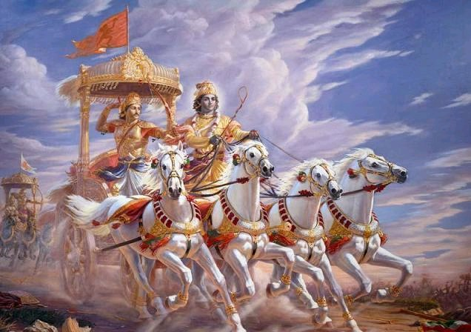
In this picture of Krishna and Arjuna, there is much symbolism in regards to our senses and keeping control of them.
The Chariot – Is likened to the body
The Horses – Are representative of the senses
Arjuna – represents the mind
Krishna (the Charioteer) – signifies the higher intellect or buddhi

It is the nature of horses to follow their animal instincts and run free wherever they like. The mind must be strong in order to give the body and senses orders for direction. However, a strong Intellect / Buddhi can overcome a weak mind and convince the mind towards a righteous path (Through Gayatri Mantra).
4) Questions for Reflection
1) What does Brahmacharya mean to you?
2) Do you think that letting the senses lead is a good idea?
3) What are some ways in which we can control our own senses?
4) Which one of the senses do you feel is the hardest to control?
5) Technique or Practice - Any practical technique the students can use (optional)
1) Each time you come across someone who offers you gossip or speaks negatively of others, simply decline their offer and tell them you don’t want to hear it, walk away.
2) Remind yourself every morning that you are a human being, a step above an animal, and that you have a responsibility to control your own animal instincts
3) Seek out positive tv shows or websites rather than the ones that portray violence or other inappropriate material on the tv or internet.

