Gayatri Gyan Kendra of Long Island
Indian Culture Group 1-3 February 12, 2012
***********************************************************************

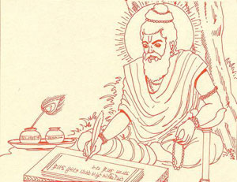
In Hinduism there are many religious books. The following religious books are the main books:

Vedas:
Vedas: There are four different books of Vedas. Vedas word derived from Sanskrit word “Vid” means to know. Therefore, Vedas means “Knowledge” It is eternal divine knowledge with no beginning and no ending. Our Rishis have experienced this knowledge in deep meditation and then written down.
There are 4 Vedas –Names are given on the left side.
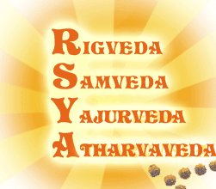

Upanishads:
The word Upanishad consists of three parts:
Upa (near), Ni (down), and Shad (sit).
Thus Upanishad means 'sitting near a teacher and receiving the secret teachings.’ Upanishads are the divine revelations received by ancient saints. They represent the essence of the Vedas, the greatest truths ever known to mankind.
There are more than 220 Upanishads available but only 108 Upanishads are more popular.

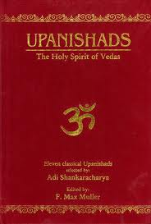

Puranas:
There are 18 Puranas. The Puranas form the largest body of Smriti (Smriti means Remember –Memorized) literature. They were developed, in a question and answer form, to explain the subtle teachings of the Vedas through stories and legends of the ancient kings, heroes, sages, and divine personalities.

Param Pujya Gurudev wrote 19th Purana called “Pragya Puran” related to “Pragyavatar” reincarnation of Lord Vishnu in 21st Century in the form of “Pragya” (Vivek or supreme form of Wisdom)

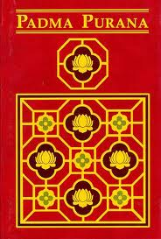

Gita:
Gita is a conversation between Lord Krishna and the Pandava prince Arjuna that took place in the middle of the battlefield before the start of the war. Arjun was confused about right and wrong and if it was proper to fight against his own cousins. The Lord Krishna explained to Arjuna his duties as a warrior and prince, and explained different ways in which the soul can reach the Supreme Being with examples and analogies. This has led to the Gita often being described as a concise guide to Hindu theology .

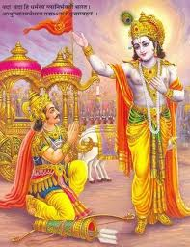

Ramayana:

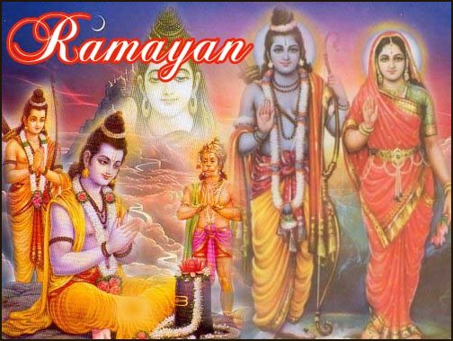
The name Ramayana compound of Rāma and ayana ("going, advancing"), translating to "Rama's Journey". The Ramayana tells the story of Lord Rama his self control, discipline and victory of good over evil.

Yug Rishis
Yugrishi,VedmurtiTaponistha
Pt. Shriram Sharma Acharya

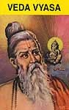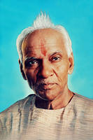
Compiled for Sat Yug
- 4 Vedas
- 108 Upansihads
- 18 Puranas
- Mahabharat
- Shrimad Bhagwat
- Gita

For expected New Era in 21stCentury –Translated and Compiled in simple language
- 4 Vedas
- 108 Upanishads –Additional Upanishad“Pragyopnishad”
- 18 Puranas–Additional Puran“PragyaPuran”
- 6 Darshans
- 20 Smrutiya, Yog Vasistha
- GitaVishwaKosh(18 Volumes comprises of 10,000 pages)
- 108 Volumes of Vangmaya (Approx 30,000 Pages)

