PRANAYAMA
Indian Culture Group 1:

Pranayama
It consists of two words:
- Pran – Life Energy

- Ayama - Expansion

How we breathe affects how long we live. Nature is perfect example:
Rabbit
Dog
Horse
Human
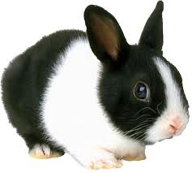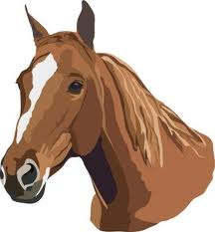
38 Breaths/Minute
Lifespan: 8 Years
28 Breaths/Minute
Lifespan: 13 Years

18 Breaths/Minute
Lifespan: 50 Years

12 Breaths/Minute
Lifespan: 100 Years

Elephant
Tortoise

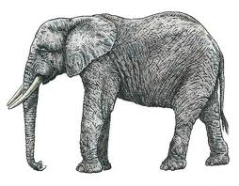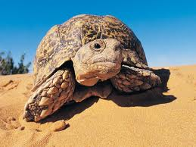
11 Breaths/Minute
Lifespan: 100 Years
4 Breaths/Minute
Lifespan: 150 Years
Our Practice:
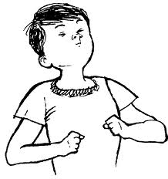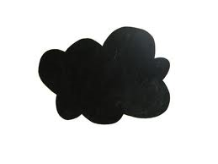
Breathe In
Breathe Out

Good In
Bad Out

